IWA Finance Special Interest Group  Meeting Agenda  Thursday, 23 July 2026  Online – Teams Teams Meeting Link  10:00am – 11:00am | 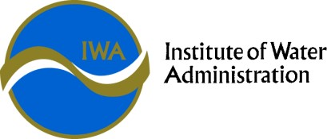

Finance SIG Objective | To consider Finance issues relevant to the Victorian Water Corporations, including industry and regulatory updates, accounting policy and standard changes, and provide for the sharing of best practice with peers.

Time | Agenda Items | Presenter
10:00am | Welcome  - Acknowledgement of country  - Convenor, Deputy Convenor and conference dates | Chang Shu, Convenor,  Manager Financial Services,  Grampians Wimmera Mallee Water (GWM Water)  Nathan Morsillo, Deputy Convenor,  Chief Financial Officer (Coliban Water)
10:05am | Around the State Update  - Annual Reports  - Key Operations, Projects, Strategies, and Innovations. | All Water Corporations  (be ready to contribute)
10:45am | DEECA Update | Annabel M Moony, Director, Sector Governance and Support (DEECA)  Etienne Gouws, Chief Financial Officer (DEECA)
10:50am | VAGO Update  - Annual Reports  - Sector Newsletter - Q&A | Tim Maxfield, Sector Director, Financial Audit  (VAGO)  Natalia Stephenson, Simon McLaren  (VAGO)
11:00am | Meeting close

- Note that this July online SIG is purposefully ‘short’ and focused given end of financial year.
- The in-person conference will be in Melbourne from the 17th to the 19th November 2026 (please block your diary). If there are topic ideas or areas, you think would be of benefit to the group – please email a convenor Chang & Nathan (Nathan.Morsillo@coliban.com.au; Chang.Shu@gwmwater.org.au)
- The Special Interest Groups (SIGs) are also trialing using a Teams Channel – and if you aren’t plugged into that, please email Chang.Shu@gwmwater.org.au

