Agenda  IWA DEVELOPMENT SERVICES SIG Meeting  Thursday 23rd July 2026 | 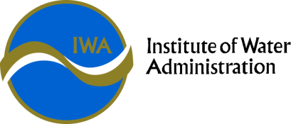

Theme: | Leading the Future
Date: | Time: | Location
Thursday 23rd July 2026 | 10:00 am – 3:30 pm SIG meeting | Microsoft Teams meeting  Join: https://teams.microsoft.com/meet/45460142090492?p=nLf83u50DTdvkZHI6G  Meeting ID: 454 601 420 904 92  Passcode: o6RV2yd3
Meeting Objective | To provide a forum to connect with peers and enhance the standard of administration for development activities in the Victorian Water Industry.

INVITEES: | Greater Western Water –  Gippsland Water –  South East Water –  Yarra Valley Water –  South Gippsland Water –  East Gippsland Water –  Barwon Water –  Coliban Water –  Lower Murray Water –  Central Highlands Water –  Goulburn Valley Water –  GWM Water –  North East Water –  TasWater –  Westernport Water –  Wannon Water -
GUESTS: | SPEAR
APOLOGIES:

Item No. | Allocated Time | Description | Presenter
 | 5 minutes | Welcome and Acknowledgement of Country | Convenor
 | 30 minutes | Administration & Introductions | Attendees
 | 90 minutes | SPEAR Overview, Functionality & Capabilities | SPEAR
 | 60 minutes | BREAK
 | 30 minutes | Connections Policy & Price Submission Preparations | Working Group
 | 60 minutes | What’s in the Water (Insights & Learnings) | Convenor
 | 120 minutes | Around the Grounds | Attendees
 | 15 minutes | SIG Online Forum | Convenor
 | 15 minutes | Next meeting | Convenor
 |  | CLOSE

