Meeting Agenda  HR Special Interest Group  Thursday 12 March 2026  Online | 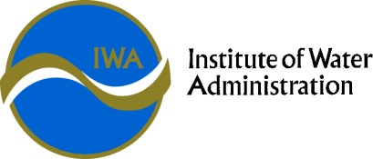

HR SIG Objective | The SIG exists to provide a forum for sharing, collaboration, networking, problem solving and professional development in the Victorian water industry.

Time | Agenda Item | Presenter
10:00 | Welcome  Acknowledgement of Country  Introductions:  - new co-convenors  - around the room | Bruce & Andy
10:10 | Plenary Debrief  - Key take aways  - Sharing of HR experience in contributing to incident management | All
10:45 | Break
11:00 | SIG Topics for the year ahead  Help set your agenda – what would we like to hear more about this year?  - Difficult Conversation Coaching  - Salary Maintenance | All  Andy Clark – GWM  Kate Montgomery - GVW
11:15 | MEA/EBA Discussion  Share your updates | All
11:30 | Updates from around the state  Open discussion – share your successes & ask for input from the brains trust | All
12:00 | Meeting end

