Meeting Agenda  Finance Special Interest Group – Thursday, 12 March 2026  Online – Teams Teams Meeting Link  10:00am – 11:00am | 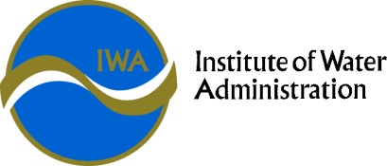

Finance SIG Objective | To consider Finance issues relevant to the Victorian Water Corporations, including industry and regulatory updates, accounting policy and standard changes, and provide for the sharing of best practice with peers.

Time | Agenda Item | Presenter
10:00am | Welcome  - Acknowledgement of country  - Agenda  - Call for Deputy Convenor | Chang Shu, Manager Financial Services, Grampians Wimmera Mallee Water (GWM Water)
11.00am | Around the State Update  Operations, Projects, Strategies, & Innovations | All Water Corporations
11:00am | Meeting close

