Meeting Agenda  Finance Special Interest Group – Thursday, 20 November 2025  Novotel Geelong, 10/14 Eastern Beach Rd, Geelong  9:00am – 3:30pm | 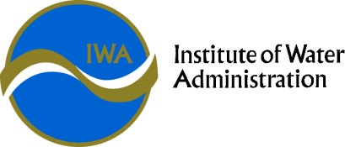

Finance SIG Objective | To consider Finance issues relevant to the Victorian Water Corporations, including industry and regulatory updates, accounting policy and standard changes, and provide for the sharing of best practice with peers.

Time | Agenda Item | Presenter
09.00 am | Arrival – Tea/Coffee
09.15 am | Welcome  - Acknowledgement of country  - Housekeeping  - Agenda | Darren (Daz) Collins, CFO, Barwon Water
09.30 am | JOINT SESSION WITH IT SIG  - Presentation and discussion, facilitated by Melissa Thek | Melissa Thek, Utilities Strategy Advisory
10.30am | Morning Tea
11.00 am | Around the State  Operations, Projects, Strategies, & Innovations | All Water Corporations
11.45 am | Economic update | Phin Ziebell – Treasury Corporation Victoria
12.30 pm | Lunch
1.00 pm | Finance as an enabler of Self-Determination: Embedding Treaty Principles into Financial Strategy | Greg Robinson – Head of First Nations Values - Barwon Water
1.45 pm | AI and Finance – Use Cases | Jack Steele – FromHereOn
2.30 pm | Meeting close/Optional networking

