IWA SPECIAL INTEREST GROUP
ENERGY AND GREENHOUSE
CHARTER
IWA has a proud history, commencing life as a group of Water and Sewerage Trust Secretaries in Gippsland getting together in 1967 to share ideas and experiences to improve their individual and collective administrative capability and performance.
The IWA now still exists to provide a forum for sharing information, networking and professional development in the Victorian water industry.
The IWA specifically assists executive management and professionals managing business related functions within all Victorian water corporations.
The IWA provides a means for Victorian water industry staff to meet and exchange ideas helping build professional networks across the industry. This in turn provides benefits to all businesses in the State through collaborative efforts and sharing of information.
The IWA is governed by an Executive Council who are elected representatives from within the industry who are also individual IWA members.
The IWA Special Interest Groups (SIGs) focus on a range of business functions within water corporations. SIGs report to the Executive Council who in turn support the activities of all SIGs ensuring they are addressing appropriate issues and providing value to the industry as a whole.
PURPOSE
The Energy and Greenhouse SIG exists to provide a forum for sharing information, networking and professional development in the Victorian water industry.
OBJECTIVES
To consider energy and greenhouse issues relevant to the Victorian Water Corporations, including:
- Energy and greenhouse gas management
- Change management
- Professional development
- Governance
- Support to meet obligations
- Opportunities for collaboration
- Specific technical elements include:
  - Systems for emissions management
  - Support decision making balancing regarding emissions reduction and offsets
  - Impact of climate change on energy and greenhouse gas emissions management and vice versa.
ACTIVITIES
- Provide a forum for interaction at all levels around strategic energy and greenhouse gas management issues
- Provide value to energy and greenhouse management practitioners and to current and aspiring practitioners, within water corporations and associated organisations
- Share information, learn from each other’s experiences and identify and adopt best appropriate practice
- Foster networks and communications between water sector practitioners.
TIMEFRAME
Ongoing
GROUP MEMBERSHIP
Open to all individuals with appropriate responsibilities in rural, regional and urban water corporations in Victoria, including Vicwater.
MEETING ATTENDEES
Relevant staff from DEECA and WSAA are also more than welcome to attend meetings. Relevant guest speakers are encouraged.
POLICIES
SIGs may create Policies. These can only be endorsed industry wide through the approval of the IWA Executive and subsequent escalation to the VicWater Board.
MEETINGS
Meetings will be held at least 3 times per annum, in accordance with the scheduled IWA conferences. The Convenor may call additional meetings when appropriate.
ANNUAL REPORTS
Convenors are to submit a report on the group’s functions for the prior financial year including outcomes on all meetings, topics and emerging issues the group addressed. The report is to be submitted to the Public Officer in August each year for inclusion in the IWA Annual Report.
MEETING PROCEDURES
The Group will determine its own procedures for the conduct of its meetings. However, meeting procedures will be consistent with those prescribed for IWA Executive Meetings in the IWA Rules. Group Members will elect the Convenor of the Group. The term of office of the Convenor will be for a nominal period of two years, with the intention that the role rotates among water corporations.
Convenor duties will rotate between members.
MINUTES
A minute taker is to be nominated for each meeting.
The Convenor is responsible for ensuring the minutes of the meeting are circulated to the IWA Public Officer within 10 working days of the meeting.
The minutes are to include an introductory executive summary listing key themes addressed in the meeting and emerging strategic issues.
CONFIDENTIALITY
All information nominated as confidential by Group Members must remain confidential and not be divulged outside of the Group’s proceedings, other than to members of the IWA Executive.
APPROVAL AND AMENDMENT
The Group will review this Charter as required and, at least, every two years. Once amended, the Charter will be submitted to the IWA Executive for approval.
Approved by the IWA Executive.

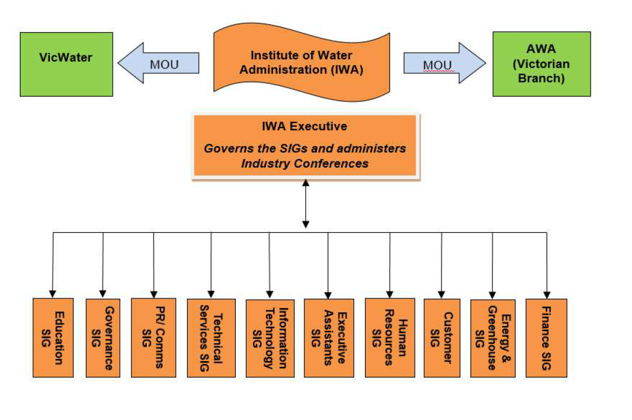

Final: 24 July 2025
Revised: NA

