Meeting Agenda  HR Special Interest Group  Thursday 24 July 2025 – MS Teams | 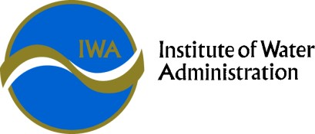

HR SIG Objective | The SIG exists to provide a forum for sharing, collaboration, networking, problem solving and professional development in the Victorian water industry.

Time | Agenda Item | Presenter
10:00 | Welcome  Acknowledgement of Country  Introductions & Check in  Overview of Agenda  Update on SIG convenor | Kate Montgomery (GVW)
10.15 | D&I Updates  Gender Equality Act Actions for 2025  - Reporting Requirements  - New GEAP development  - Learnings from the first GEAP  - VicWater DEI Practitioner Group shared GEAP Actions | Elaine Dixon
11:00 | Employee Wellbeing  Share and Benchmark across the state:  - EAP  - Health Checks  - Gym memberships | All
11:30 | Break
11.45 | IR Update  - Multi Enterprise Agreements (MEA)  - Fles Work Update | VGSO  Frances Anderson – Assistant Vic Gov Solicitor
12.15 | Updates from around the state  Including EA update & Innovation  - Network Discussion threads | All
13.00 | Meeting end

Next Meeting: IWA Annual Conference and SIG, Novotel Geelong Nov 19 & 20

