Meeting Agenda  Customer Special Interest Group – July 2025  Teams 10:00am – 2.30pm | 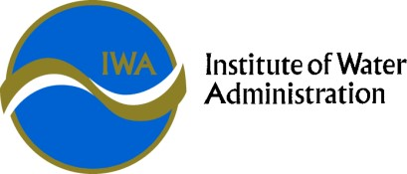

Customer Service SIG Purpose | The Customer Service SIG exists to provide a forum for sharing, collaboration, networking, problem solving and professional development for people working in Customer domains in the Victorian water industry, ultimately contributing to improved products, services and customer experiences.

Time | Agenda Item | Presenter
10:00 | Welcome  - Acknowledgement of country  - Confirmation of minutes of previous meeting  - Confirmation of minute taker | Alison Flintoff, Yarra Valley Water
10.10 | - Backbilling Working Group update  - ESC Guideline 2 (2025): Adjustment of bills | - Peter Dichiera, Lower Murray Water  - All
10:55 | Family Violence Working Group Update | Amy Rouse, Coliban Water
11.10 | Debt Collection Working Group Update | Amy Rouse, Coliban Water
11.20 | What is the Thriving Communities Australia – One Stop One Story Hub and how can customers benefit from it?. | Rob Morgan, Yarra Valley Water  Stephen McLean, South East Water
11.45 | Language Preferences in CRM | Hannah Ellingford, South East Water
12:00 | Lunch
12:30 | Caveats – Lessons & learnings from LMW | Wendy Davison, Lower Murray Water
1.00 | Complaints Working Group Update | Alison Flintoff for Anna Whitworth, Yarra Valley Water
1:05 | Collections Approaches & Effectiveness, including impact of restrictions if used  . | Everyone to pre submit 1-2 slides
1.35 | 2 slides – Hardship Programs | Go through slides as a group & discuss / ask questions
2:05 | DFFH Working Group update | Rob Morgan, Yarra Valley Water
2:10 | General Business
2:25 | Meeting wrap up – what worked well, what didn’t what do we want on agenda for 20 November in person meeting? | All
2:30 | Meeting end

Next Meeting: In person - Novotel Geelong – Thursday 20th November

