Meeting Agenda  HR Special Interest Group  Thursday 24 July 2025 – MS Teams | 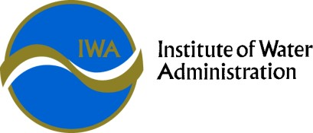

HR SIG Objective | The SIG exists to provide a forum for sharing, collaboration, networking, problem solving and professional development in the Victorian water industry.

Time | Agenda Item | Presenter
10:00 | Welcome  Acknowledgement of Country  Introductions & Check in  Overview of Agenda  Update on SIG convenor | Kate Montgomery (GVW)
10.15 (tentative) | WIOA Network Operator Development Program 10 Year Anniversary | Dean Barnett (WIOA)
11:00 (confirmed) | IR Update & Multi Enterprise Agreements (MEA)  Continuation of discussions recently with DEECA | VGSO  Frances Anderson – Assistant Vic Gov Solicitor
11:30 | Break
11.45 | Employee Wellbeing  Benchmarking offerings across the state:  - EAP  - Health Checks  - Gym memberships | Discussion
12.15 | D&I Updates
12.45 | Updates from around the state  Including EA update & Innovation  Network Discussion threads | All
1.30pm | Meeting end

Next Meeting: IWA Annual Conference and SIG, Novotel Geelong Nov 19 & 20

