Agenda  IWA DEVELOPMENT SERVICES SIG Meeting  Thursday 24th July 2025 | 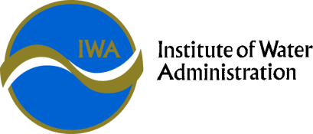

Theme: | Leading the Future
Date: | Time: | Location
Thursday 24th July 2025 | 10:00 am – 4:00 pm SIG meeting | Virtual Meeting – MS Teams  Microsoft Teams  Join the meeting now  Meeting ID: 479 414 485 808 6  Passcode: A39zM79i
Meeting Objective | To provide a forum to connect with peers and enhance the standard of administration for development activities in the Victorian Water Industry.

INVITEES: | Greater Western Water –  Gippsland Water –  South East Water –  Yarra Valley Water –  South Gippsland Water –  East Gippsland Water –  Barwon Water –  Coliban Water –  Lower Murray Water –  Central Highlands Water –  Goulburn Valley Water –  GWM Water –  North East Water –  TasWater –  Westernport Water –  Wannon Water -
GUESTS: | DEECA
APOLOGIES:

Item No. | Allocated Time | Description | Presenter
 | 5 minutes | Welcome and Acknowledgement of Country | Convenor
 | 10 minutes | Introductions | Attendees
 | 15 minutes | Administration | Convenor
 | 90 minutes | DEECA – Victorian Housing Statement and Reporting Metrics | DEECA
 | 15 minutes | BREAK
 | 30 minutes | What’s in the Water (Insights & Learnings) | Convenor
 | 120 minutes | Around the Grounds | Attendees
 | 15 minutes | Next meeting | Convenor
 |  | CLOSE

