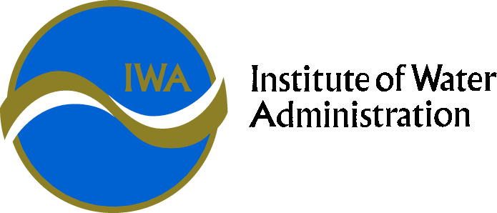

IWA EXECUTIVE ASSISTANTS’ SPECIAL INTEREST GROUP (SIG)

CHARTER

IWA has a proud history, commencing life as a group of Water and Sewerage Trust Secretaries in Gippsland getting together in 1967 to share ideas and experiences to improve their individual and collective administrative capability and performance.

The IWA now still exists to provide a forum for sharing information, networking and professional development in the Victorian water industry.

The IWA specifically assists executive management and professionals managing business related functions within all Victorian water corporations.

The IWA provides a means for Victorian water industry staff to meet and exchange ideas helping build professional networks across the industry. This in turn provides benefits to all businesses in the State through collaborative efforts and sharing of information.

The IWA is governed by an Executive Council who are elected representatives from within the industry who are also individual IWA members.

The IWA Special Interest Groups (SIGs) focus on a range of business functions within water corporations. SIGs report to the Executive Council who in turn support the activities of all SIGs ensuring they are addressing appropriate issues and providing value to the industry as a whole.

**PURPOSE**

The Executive Assistants’ SIG exists to provide a forum for sharing information, networking and professional development in the Victorian water industry.

**OBJECTIVES**

* The EA SIG will ensure ongoing professional development of its members. This will take the form of a workshop held once a year.
* To consider and gain continuous improvement in Executive Assistant SIG issues relevant to the Victorian water corporations, including:
* Board meeting process
* Acts, regulations and compliance activities across the industry
* Best practice governance practices
* Forum issues applicable to all businesses such as policies, appointment processes, storage of information etc

**ACTIVITIES**

* Provide a forum for interaction at all levels around strategic Executive Assistant issues;
* Share information, learn from each other’s experiences and identify and adopt best appropriate practice;
* EA SIG members will have access informally to all SIG Members in between meetings if advice is required on a relevant issue; and
* Foster networks and communications between water sector

**TIMEFRAME**

Ongoing

**GROUP MEMBERSHIP**

Open to all individuals with appropriate responsibilities in Executive Assistant related functions in rural, regional and urban water corporations in Victoria. The EAs/PAs to CEO’s/MD’s may, at their discretion invite 1 x EA/PA from their business to attend a particular meeting as their guest or alternatively attend on their behalf if they are unable to attend a particular meeting. The Executive Assistants’ SIG has a strong link with the Governance SIG and will meet jointly from time to time.

**POLICIES**

SIGs may create policies. These can only be endorsed industry wide through the approval of the IWA Executive and subsequent escalation to the VicWater Board.

**MEETINGS**

Meetings will be held at least 3 times per annum, in accordance with the scheduled IWA conferences. Meeting venues will depend on location of the Regional Conferences and may be held at a water business venue.

The Convenor may call additional meetings when appropriate

**ANNUAL REPORTS**

Convenors are to submit a report on the group’s functions for the prior financial year including outcomes on all meetings, topics and emerging issues the group addressed. The report is to be submitted to the Public Officer in August each year for inclusion in the IWA Annual Report.

**MEETING PROCEDURES**

The Group will determine its own procedures for the conduct of its meetings. However, meeting procedures will be consistent with those prescribed for IWA Executive Meetings in the IWA Rules.

Group Members will elect the Convenor of the Group. The term of office of the Convenor will be for a maximum of two years, with the intention that the role rotates among water corporations.

The Group Convenor must be endorsed by the IWA executive.

Convenor duties will rotate between members.

**MINUTES**

The Convenor is responsible for ensuring the minutes of the meeting are circulated to the IWA Public Officer within 7 working days of the meeting.

The minutes are to include an introductory executive summary by the convenor listing key themes and emerging strategic issues from the meeting.

**MEMBERSHIP**

Convenors must become a member of the IWA within 6 months of being endorsed as the SIG convenor.

**CONFIDENTIALITY**

All information nominated as confidential by Group Members must remain confidential and not be divulged outside of the Group’s proceedings, with the exception of Minutes being submitted to the IWA Executive.

**APPROVAL AND AMENDMENT**

The Group will review this Charter as required and, at least, every two years. Once amended, the Charter will be submitted to the IWA Executive for approval.

Approved by the IWA Executive on 15/03/2013.

**Institute of Water Administration (IWA)**

**VicWater**

**AWA (Victorian Branch)**

MOU

MOU

**IWA Executive**

**Governs the SIGs, administers Conferences**

**Energy and Greenhouse SIG**

**HR SIG**

**IT SIG**

**Customer SIG**

**Finance SIG**

**EA SIG**

**Tech Services SIG**

**PR/Comms SIG**

**Governance SIG**