|  |  |  |  |
| --- | --- | --- | --- |
|  | | | |
|  |  |  |  |

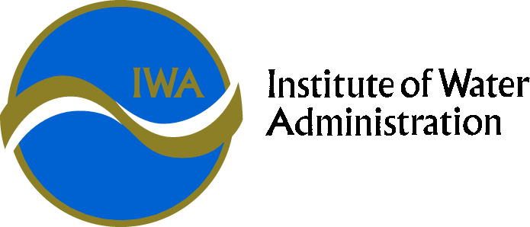

IWA SPECIAL INTEREST GROUP – Environment

CHARTER

IWA has a proud history, commencing life as a group of Water and Sewerage Trust Secretaries in Gippsland getting together in 1967 to share ideas and experiences to improve their individual and collective administrative capability and performance.

The IWA still exists now to provide a forum for sharing information, networking and professional development in the Victorian water industry.

The IWA specifically targets offerings to executive management and professionals managing business related functions within all Victorian Water Corporations.

The IWA provides a means for Victorian Water Industry staff to meet and exchange ideas helping build professional networks across the industry. This in turn provides benefits to all businesses in the State through collaborative efforts and sharing of information.

The IWA is governed by an Executive Council who are elected representatives from within the water industry who are also individual IWA members.

The IWA’s Special interest groups (SIGs) focus on a range of business functions within water corporations. SIGs report to the Executive Council who in turn support the activities of all SIGs ensuring they are addressing appropriate issues and providing value to the industry as a whole.

**PURPOSE**

The Environment Special Interest Group exists to provide a forum for information sharing, networking and professional development in the Victorian water industry.

**OBJECTIVES**

To consider Environmental and Regulatory issues relevant to the Victorian Water Corporations, including, but not limited to:

* Environment Protection Authority
* Emerging contaminants
* Groundwater contamination
* Organisational environmental risk
* Environmental Management Systems
* *Environment Protection Act* and other legislation.
* Knowledge sharing between authorities
* Asbestos and other prescribed waste management
* Treated effluent discharge

**ACTIVITIES**

* Provide a forum for interaction at all levels around strategic Environment Special Interest Group issues;
* Contribute positively to environmental management within water corporations and support environmental specialists with these and associated organisations;
* Share information, learn from each other’s experiences and identify and adopt best practice environmental management, and;
* Foster networks and communications between water sector businesses and employees.

**TIMEFRAME**

Ongoing

**GROUP MEMBERSHIP**

Open to all individuals with relevant responsibilities in Environmental Management related functions in rural, regional and urban water corporations in Victoria.

**POLICIES**

SIGs may create Policies. These can only be endorsed industry wide through the approval of the IWA Executive and subsequent escalation to the VicWater Board.

**MEETINGS**

Meetings will be held at least 3 times per annum, in accordance with the scheduled IWA conferences.

The Convenor may call additional meetings when/if appropriate.

**ANNUAL REPORTS**

Convenors are to submit a report on the group’s functions for the prior financial year including outcomes on all meetings, topics and emerging issues the group addressed. The report is to be submitted to IWA’s Public Officer in August each year for inclusion in the IWA Annual Report.

**MEETING PROCEDURES**

The Group will determine its own procedures for the conduct of its meetings. However, meeting procedures will be consistent with those prescribed for IWA Executive Meetings in the IWA Rules.

Group Members will elect the Convenor of the Group. The term of office of the Convenor will be for a nominal period of two years, with the intention that the role rotates among water corporations.

The Group Convenor must be endorsed by the IWA executive.

**MINUTES**

The Convenor is responsible for ensuring the minutes of the meeting are circulated to the IWA Public Officer within 7 working days of the meeting.

The minutes are to include an introductory executive summary by the convenor listing key themes and emerging strategic issues from the meeting.

**MEMBERSHIP**

Convenors must become a member of the IWA within 6 months of being endorsed as the SIG convenor.

**CONFIDENTIALITY**

All information nominated as confidential by Group Members must remain confidential and not be divulged outside of the Group’s proceedings, other than to members of the IWA Executive.

**APPROVAL AND AMENDMENT**

The Group will review this Charter as required and, at least, every two years. Once amended, the Charter will be submitted to the IWA Executive for approval.

Approved by the IWA Executive on XX/XX/XXXX

**Institute of Water Administration (IWA)**

**VicWater**

**AWA (Victorian Branch)**

MOU

MOU

**IWA Executive**

**Governs the SIGs, administers Conferences**

**Environment SIG**

**Education SIG**

**Tech Services SIG**

**Elec and Greenhouse SIG**

**HR SIG**

**EA SIG**

**Governance SIG**

**PR/Comms SIG**

**Finance SIG**

**Customer SIG**

**IT SIG**