Agenda  IWA DEVELOPMENT SERVICES SIG Meeting  Thursday 20th March 2025 | 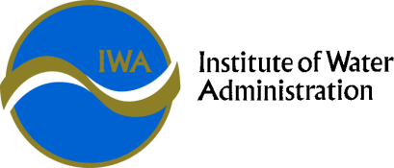

Theme: | Leading the Future
Date: | Time: | Location
Thursday 20th March 2025 | 10:00 am – 3:30 pm SIG meeting | Virtual Meeting – MS Teams  Join the meeting now  Meeting ID: 475 206 755 391  Passcode: Be63Wv3J
Meeting Objective | To provide a forum to connect with peers and enhance the standard of administration for development activities in the Victorian Water Industry.

INVITEES: | Greater Western Water –  Gippsland Water –  South East Water –  Yarra Valley Water –  South Gippsland Water –  East Gippsland Water –  Barwon Water –  Coliban Water –  Lower Murray Water –  Central Highlands Water –  Goulburn Valley Water –  GWM Water –  North East Water –  TasWater –  Westernport Water –  Wannon Water -
GUESTS: | Association of Land Development Engineers
APOLOGIES:

Item No. | Allocated Time | Description | Presenter
 | 5 minutes | Welcome and Administration | Convenor
 | 10 minutes | Introductions | Attendees
 | 15 minutes | Replay and actions from November SIG | Convenor
 | 30 minutes | SIG Working Groups | Deputy Convenor
 | 30 minutes | Consistency in lexicon and terminology | Convenor
 | 15 minutes | BREAK
 | 45 minutes | ALDE Water Sub-Committee | ALDE representative
 | 30 minutes | Standards and Guidelines | Convenor
 | 15 minutes | BREAK
 | 45 minutes | Around the Grounds / Emerging Issues and Opportunities | Attendees
 | 5 minutes | Next meeting | Convenor
 |  | CLOSE

